## **The Micro Service**

### **Get Owner Detail By Referral Code**

**API Endpoint**: <http://localhost:8000/process>

**Method Type:** POST

**API Headers:**

Content-Type: application/json

**API Request:**

{

"referralcode": "T6R9N"

}

**API Response:**

{

"referralcode": [

"Referral Code must be at least 6 characters!",

"Referral Code doesn't exist!"

]

}

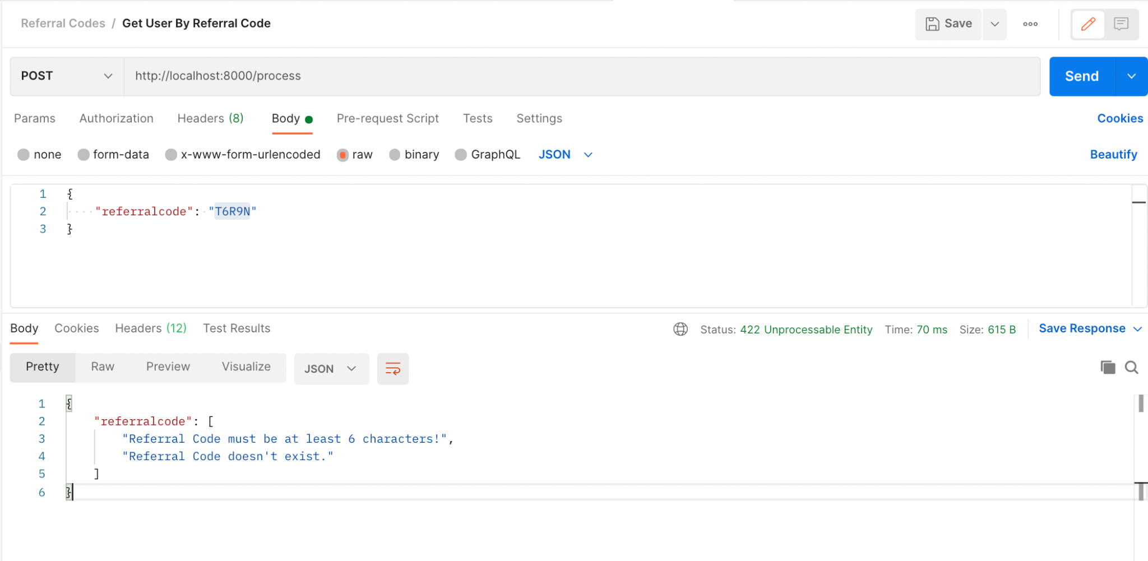

**API Request:**

{

"referralcode": "T6R9NO"

}

**API Response:**

{

"id": 2,

"name": "Stephen Martin",

"email": "stephen@gmail.com",

"contact_number": "+65-45646455",

"value": "T6R9NO",

"user_id": 3,

"credits": 25,

"balance": 25,

"no_of_referrals_acquired": 0,

"min_amount_for_redemption": 50

}

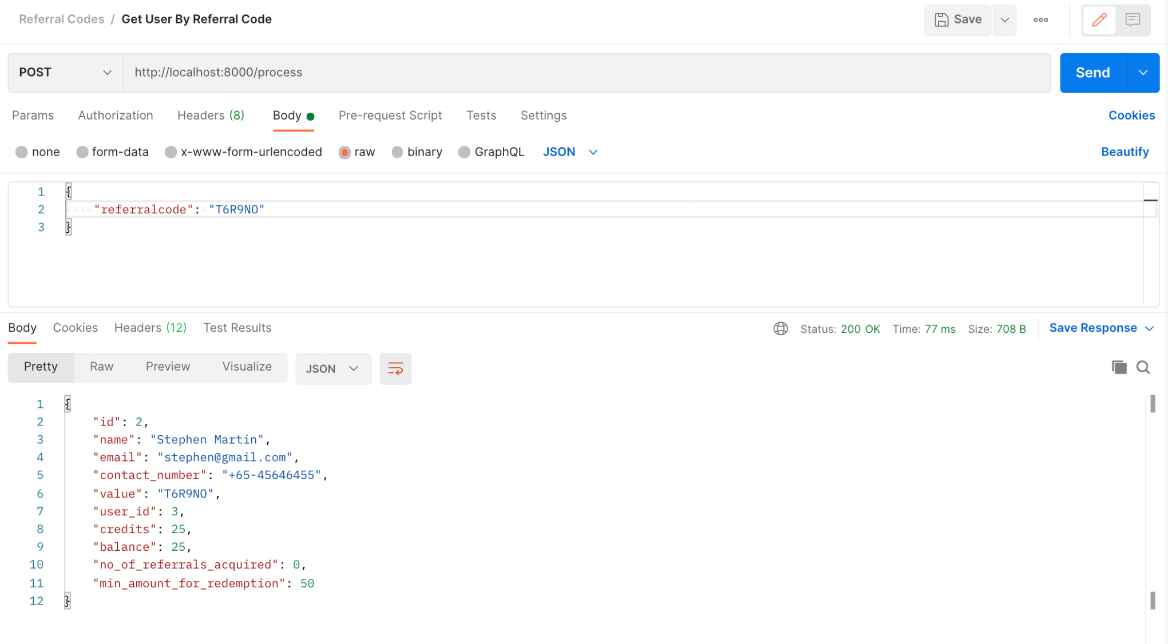

## 

### **Get Referral Codes**

**API Endpoint**: <http://localhost:8000/referralcodes>

**Method Type:** GET

**API Headers:**

Content-Type: application/json

**API Request:** NA

**API Response:**

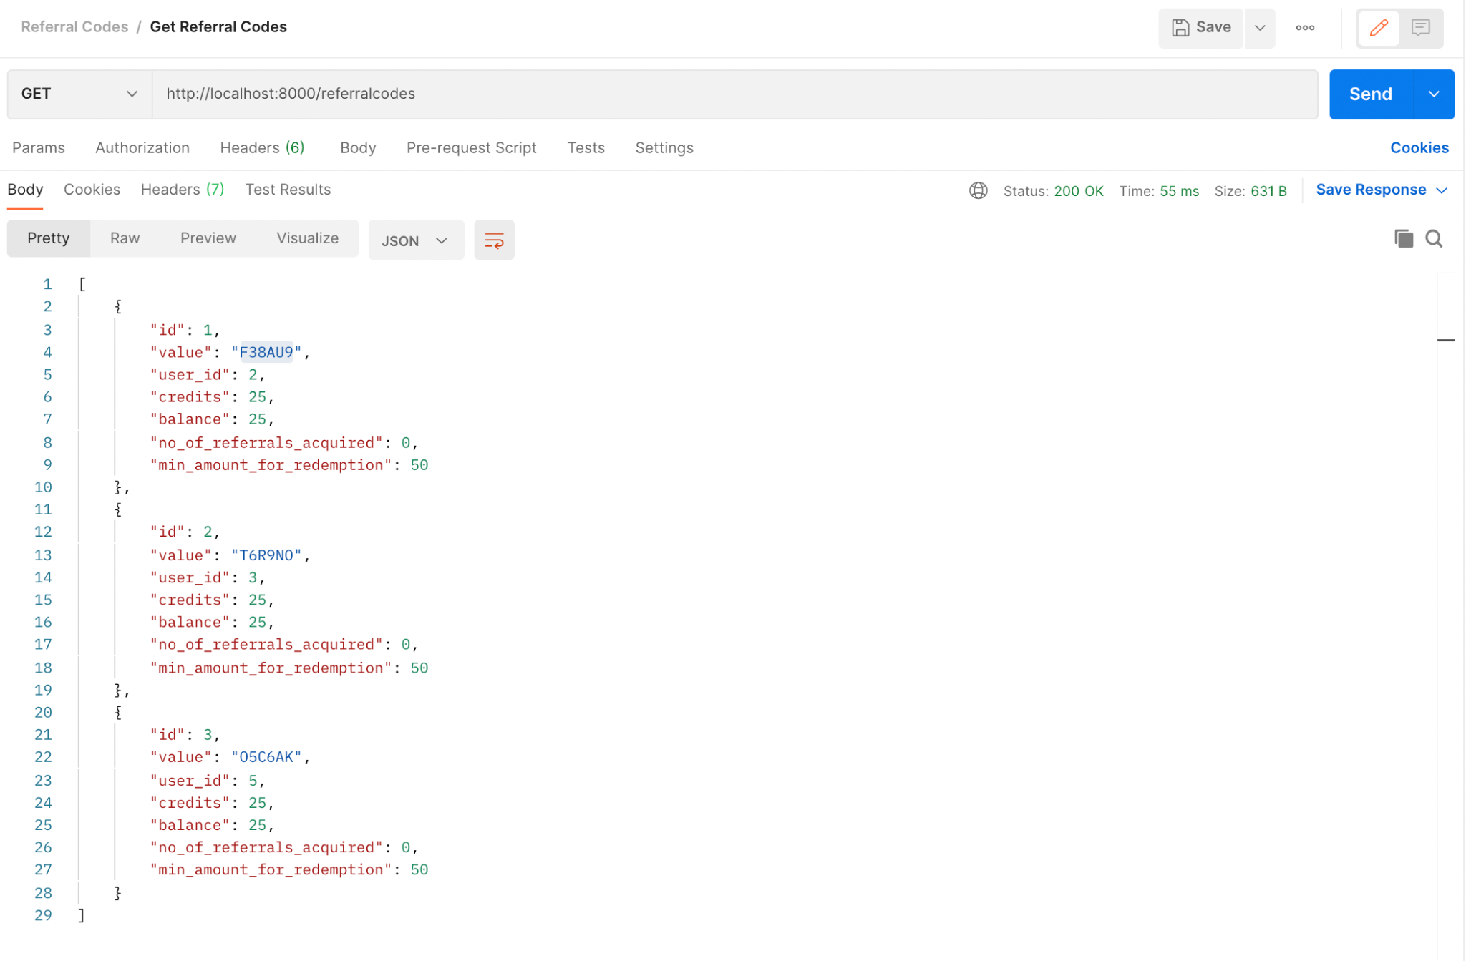

### 

### **Get Users**

**API Endpoint**: <http://localhost:8000/users>

**Method Type:** GET

**API Headers:**

Content-Type: application/json

**API Request:** NA

**API Response:**

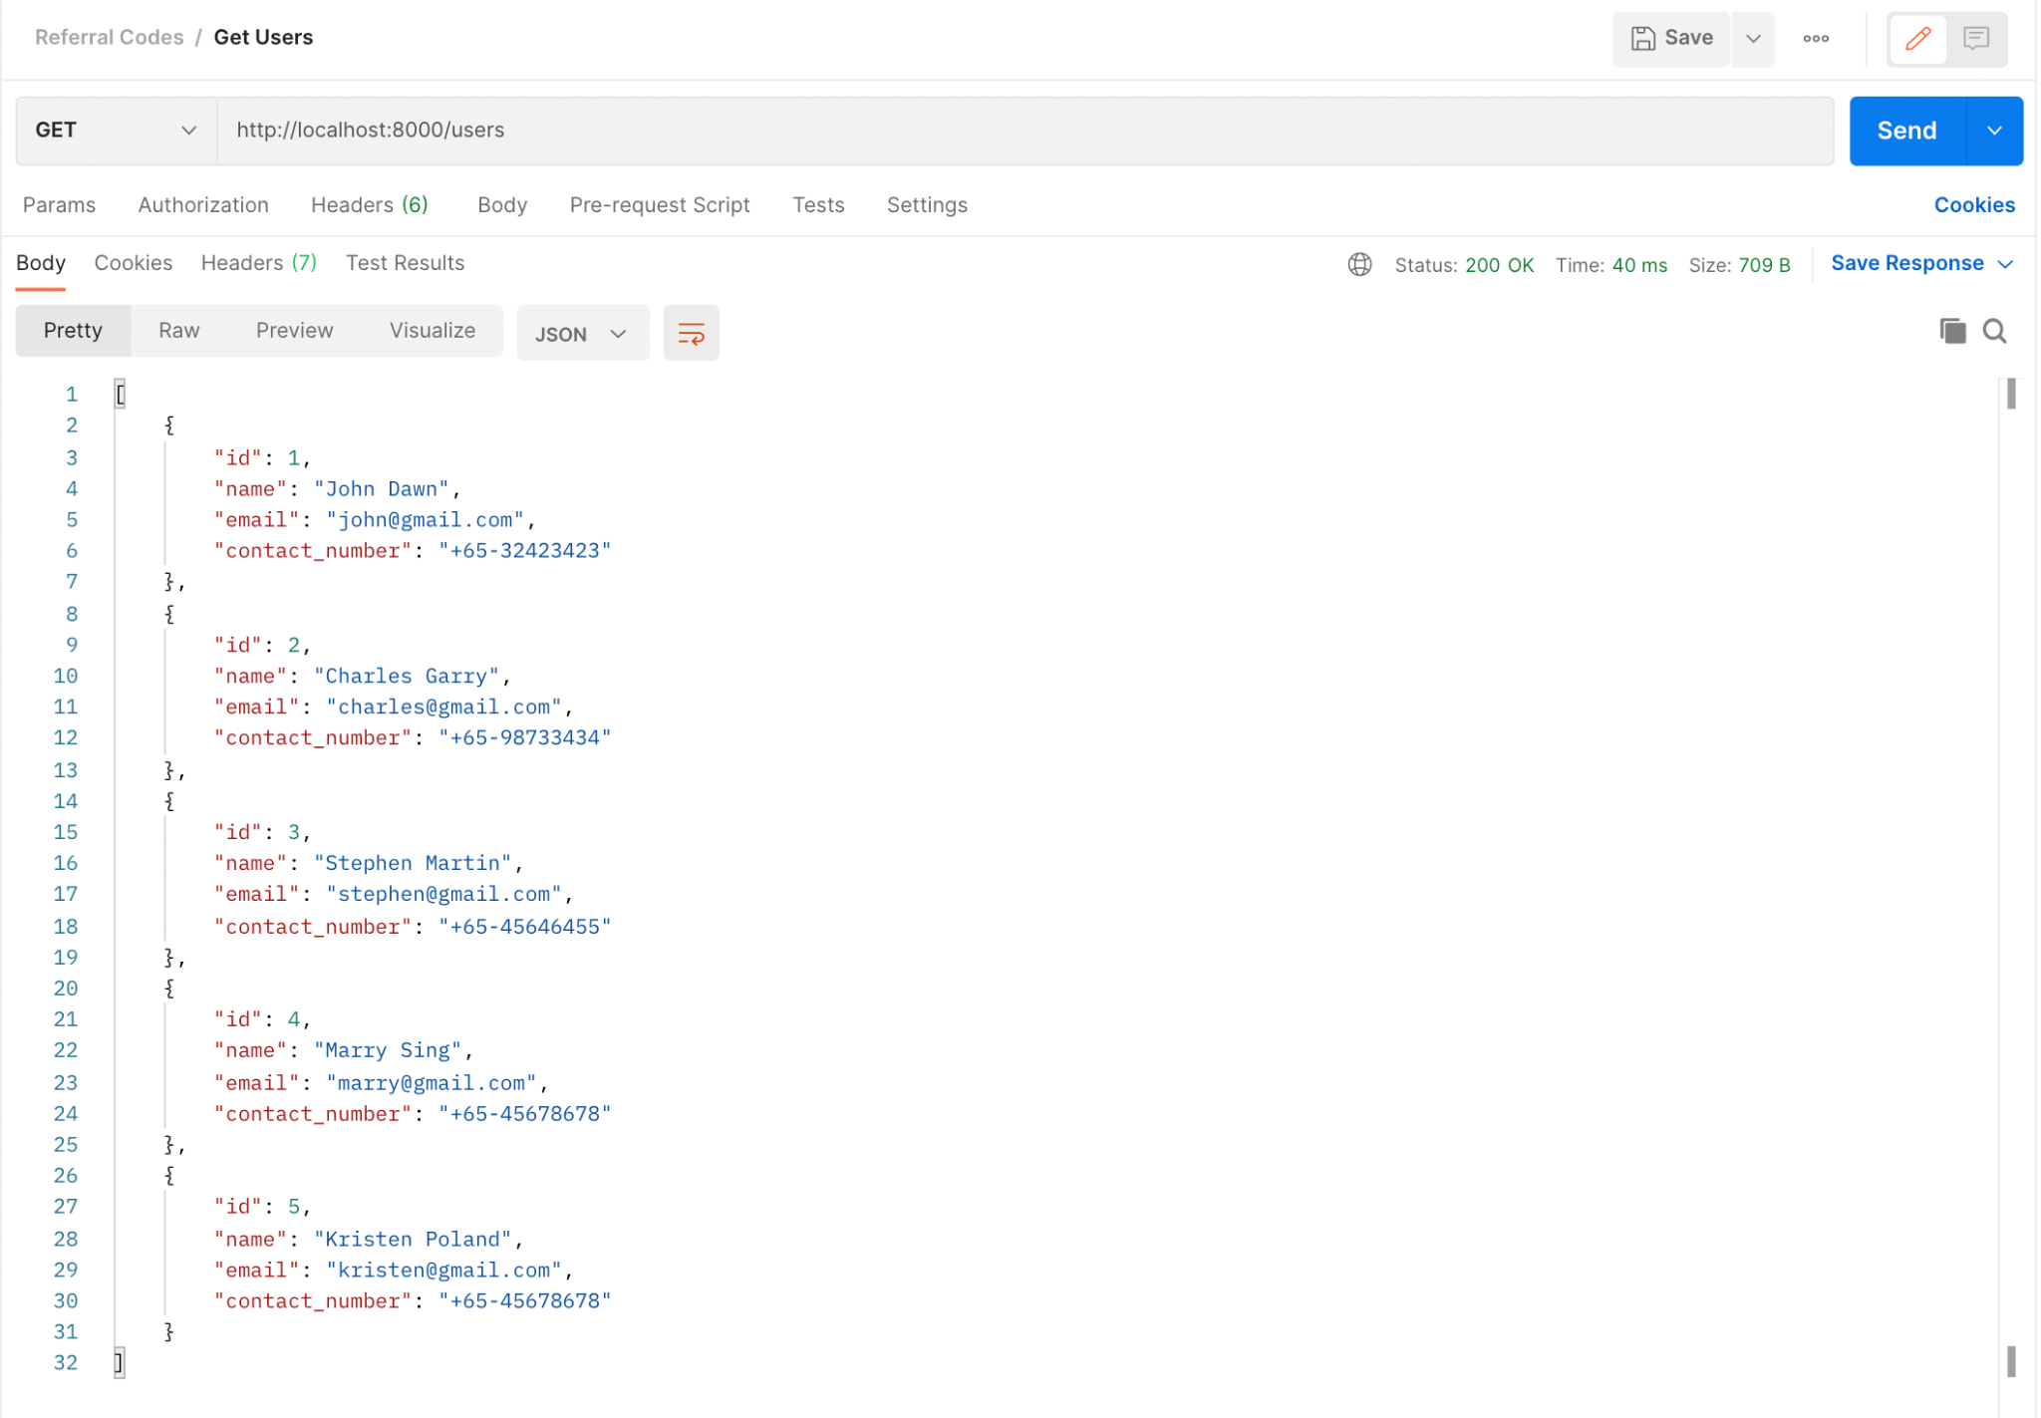

## 

## 

## 

## 

## 

## **The Web Client**

